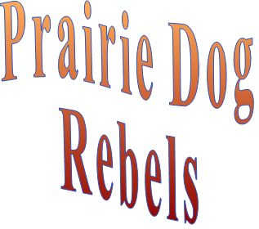
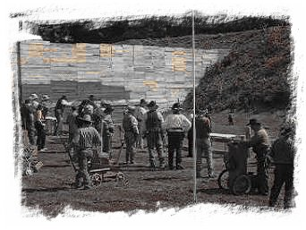
June 17, 2023
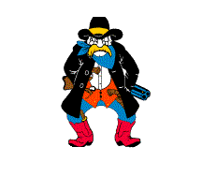
Stage One

Position 1
R 1
R 2
R3
P
1
P2
P3
S 11
S2
S3
S4
Position 2

10 Rifle - Staged on Position 2
10 Pistol
4 + Shotgun – Staged on Position 2

Shooter starts at Position 1 with hands at their side. When shooter is ready they say the following line “I reckon I’m ready if you are”. ATB draw your pistols as required and engage the pistols targets in the following order… 3 on P3, 1 on P1, 1 on P2, 3 on P3, 1 on P1, 1 on P2. Holster your pistols and move to Position 2. Pickup your rifle and engage the rifle targets in the same order as the pistols… 3 on R3, 1 on R1, 1 on R2, 3 on R3, 1 on R1, 1 on R2. Safety your rifle on Position 2 and pickup your shotgun. Engage the shotgun targets from left to right… S1, S2, S3, S4.
Stage Two

Position 1
R 1
R 2
R3
P
1
P2
P3
S 11
S2
S3
S4
Position 2

10 Rifle - Staged on Position 2
10 Pistol
4 + Shotgun – Staged on Position 2

Shooter starts at Position 1 with hands on hat. When shooter is ready they say the following line “I’ll let my irons do my talkin”. ATB draw your pistols as required and engage the pistols targets in the following order… P1, P2, P3, 2 on P2, P1, P2, P3, 2 on P2. Holster your pistols and move to Position 2. Pickup your rifle and engage the rifle targets in the same order as the pistols… R1, R2, R3, 2 on R2, R1, R2, R3, 2 on R2. Safety your rifle on Position 2 and pickup your shotgun. Engage the shotgun targets in any order.
Stage Three

Position 1
P/R
2
S1
S2

10 Rifle - Staged on Position 1
10 Pistol
4 + Shotgun – Staged on Position 1

Shooter starts at Position 1 with rifle at Cowboy Port of Arms. When shooter is ready they say the following line “I’ll be standing my ground”. ATB Engage the rifle targets in the following order… 10 on R1. Safety your rifle on Position 1 table and draw your pistols as required and engage pistol targets in the same order as the rifle… 10 on P1. Holster your pistols and pickup your shotgun and engage the shotgun targets… double tap in any order.

Stage Four

Position 1
R 1
R 2
R 3
R4
S 11
S2
S3
S4
Position 2

10 Rifle - Staged on Position 1
10 Pistol
4 + Shotgun – Staged on Position 2

Shooter starts at Position 1 with hands behind their back. When shooter is ready they say the following line “I aint gonna hit ya pilgrim but I will shoot ya”. ATB draw your pistols as required and engage the pistols targets in the following order… 2 on P1, 2 on P2, 2 on P3, 2 on P4, 1 on P1, 1 on P4. Holster your pistols and pickup your rifle and engage the rifle targets in the same order as the pistols… 2 on R1, 2 on R2, 2 on R3, 2 on R4, 1 on R1, 1 on R4. Safety your rifle on Position 1 and move to Position 2. Pickup your shotgun and engage all four shotgun targets in any order.
Stage Five

Position 1
R 1
R 2
R 3
R4
S 11
S2
S3
S4
Position 2

10 Rifle - Staged on Position 1
10 Pistol
4 + Shotgun – Staged on Position 2

Shooter starts at Position 2 with hands by their sides. When shooter is ready they say the following line “I’ll be seein ya pard”. ATB pickup your shotgun and engage the shotgun targets from right to left. Safety shotgun on position 2 and move to Position 1. Pickup your rifle and engage the rifle targets in the following order… 1 on R1, 2 on R2, 3 on R3, 4 on R4. Safety rifle and draw your pistols as required and engage the pistol targets in the same order as the rifle … 1 on R1, 2 on R2, 3 on R3, 4 on R4.

Stage Notes

Stage Raw time Misses Procedurals Total Time

1

2

3

4

5

6

Notes

